Contents

Introduction 2
Terminology 3
Data Input Tables 4
Requirements 5
Examples 6

Introduction

While it is intended for the solution to be created using D3.js, viable alternatives will be considered.
It is imperative that the solution achieves the requirements.
The intention of this engagement is to produce a proof of concept, with the view to advance to a repeatable product offering (cloud or standalone).
Additional enhancements are welcomed, once the core requirements are sufficed.

Terminology

Dependency
Project B
Project D

Delivering Project – In the above example, Project B is Delivering to Project D
Receiving Project - In the above example, Project D is Receiving from Project B
The dependency is the exchange between the two projects.

In D3.js terminology:
- The projects are nodes.
- The dependency is a link.

Data Input Tables
The data input table(s) are used to define the data in order to populate the dependency map.
This data is dynamic and must be easily editable, with real-time effect on the dependency map.

Dependencies
Field | Dependency ID | Dependency Name | Dependency Description | Delivering Project | Receiving Project | Baseline Date | Forecast Date | Dependency Status
Data type | Free text | Free Text | Free Text | Free Text | Free Text | Date | Date | Choice (Text)
Example | DEP-01 | Project A depends on Project B to deliver XYZ | The purpose of this dependency is to blah blah blah | Project B | Project D | 07/08/2021 | 08/09/2021 | (1) Red  (2) Amber  (3) Green

Projects
Field | Project Name | Project Status | Portfolio | Node Size
Data type | Free text | Choice (Text) | Free text | Choice (Text)
Example | Project 1 | (0) Not Started  (1) Red  (2) Amber  (3) Green  (4) Complete | Portfolio 1 | Sml  Med  Lrg

Portfolio
Field | Portfolio Name | Portfolio Colour
Data Type | Free text | Choice (Text)
Example | Portfolio 1 | Pale Blue  Pale Orange  Pale Green  Pale Gray  (I am open to suggestions for this one, whether it be names / hex / rgb)

Requirements

- Input data should be imported from Excel (xls or csv) per the Data Input Tables structure above – I am open to viable alternatives.
- The solution must be repeatable and easy to deploy (ie copy a few files and update the input data file(s) to see a while new dependency map).
- Each Dependency should have a directional arrow to identify the direction of delivery (Delivering -> Receiving).
- Each dependency line should have the Dependency ID centred above it.
- Each dependency line should be coloured according to the Dependency Status.
- Each Project Node should have the Project Name above it and the node colour set according to the Project Status (Grey / Red / Amber / Green / Blue).
- By hovering over a node or a dependency label, a dialogue box should appear showing the details for that item.
- Clicking on a Project (node) should highlight/enhance all dependencies that directly connect to that node, while greying out the other nodes/dependencies (refer Example Click on Project below)
- Projects must be grouped by Portfolio (Refer to Example Grouping below)
- Font – Arial
- Project name label should be Bold
- Dependency ID label should be Normal
- Visual / Adjustability / Refinement
- Dependencies should draw on the canvas and autofit so that they do not overlap.
- Clicking and dragging a project (node) should like a D3.js force-directed graph.
- The spacing / spread of nodes should be adjustable (closer apart / further apart)
- The size of nodes should be adjustable (small / medium / large) per the Project field Node Size
- Zoom in / out
Nice to have:
- 3D format nodes / look and feel
- Legend that has options to Show / Hide:
  - Dependency Labels
  - Project Labels
  - Dependency Status (ie show all dependency lines as black)

Examples

Example Project (Node):
Project A

Project Status

Example Dependency:
DEP-023

Example Dependency Map:
Project A
Project B
Project D
DEP-021
DEP-023
DEP-022
Project C

Example Grouping:
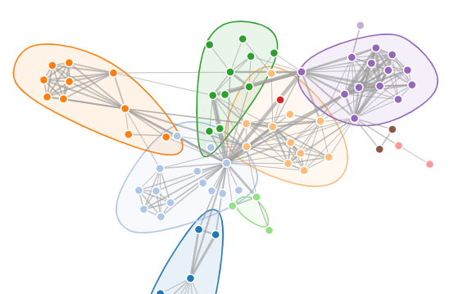
Source: https://bl.ocks.org/XavierGimenez/a8e8c5e9aed71ba96bd52332682c0399

Example Click on Project:
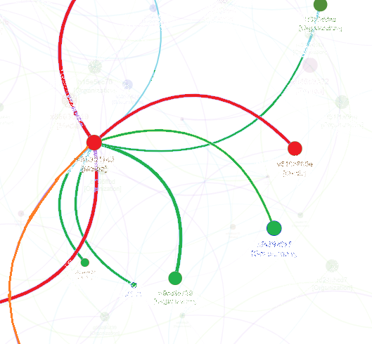
Note the above shows curved dependency lines, the intention is to stay with straight lines

